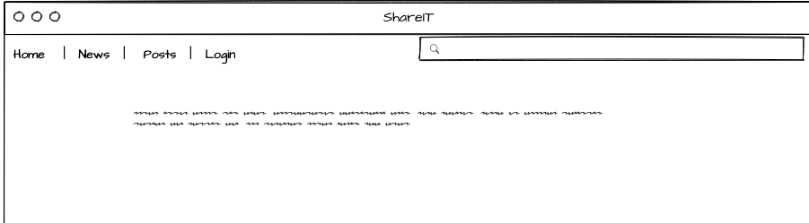

A user will come to the website for the first time and load the main page of shareIT.com and the result is a page that appears like the one above

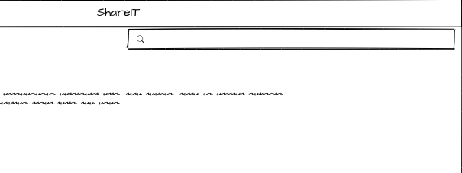

The user can then choose to search any related posts or pages within the system using certain key words that are available



If user wants to post a status anonymously or as guest, a guest id is assigned to the user and user can make anonymous post

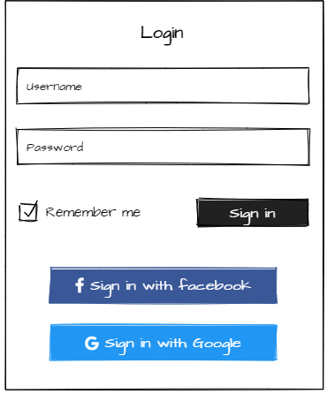

However, for a user to follow other posts and join groups, they have to login using the main window as above